**A Slice of MoMA: A Playful and Serendipitous Artwork Exploration through Interactive Data Visualization**

Yichen Jia, Qianhui Liang, Jialu Tan

School of Architecture and Urban Planning, MIT

**Abstract**

By redesigning the visualization of MoMA’s collections, we want to explore a playful and serendipitous way of displaying artworks which will stimulate random exploration rather than offering traditional education. A slice of MoMA approaches the enormous amount of artworks from the color analysis perspective. Compared to traditional virtual museums, it allows users to playfully select and compare artists, reveals the color progression of artworks, and offers recommendations on artworks with similar styles.

**Keywords**: serendipitous exploration, nested visualization, recommendation, color analysis.

# **Introduction**

Virtual experience has become a prevailing service provided by most museums. Many such official websites allow users to view and explore artworks and artists, and learn about some basic knowledge which they might overlook while actually in the museums, such as years the artworks were acquired and the materials used. These websites provide users a preview or pre-experience so that users will know what to expect for the actual visit. Museum websites have now become an important supplement to physical exhibitions.

However, as mostly seen, these websites are designed to just provide a display of current collections, usually shown in the alphabetical order by the artists’ last names. Some provide a search box where users can input the artists they are interested in, but if users forget or don’t know the exact name, it is going to take a while for them to scroll all the way down to find the place. Usually, such websites have little or no data overview for users to discover the trends hidden behind the huge quantity, to see the shared features between different artists, or to explore the artworks based on their interest. Some offer a filter where users could select their interested categories, but most don’t have such a thing. We believe visualizing the relations between artists and artworks, and providing other exploration methods other than searching will make the online experience easier and much richer, especially when users have limited knowledge of what or who to look for, or when they don’t know the museum and its collections well. Comparison and general overview should be as important as purely displaying.

MoMA is one of the leading modern art museums in the world, famous for its enormous amount of collections and a wide cover on modern artists. However, MoMA’s website has quite a number of problems as we described above. (fig.1) We’ve found that users can hardly navigate through the webpage if they have an unclear intention, but have to follow the displayed order and randomly check some artworks. The website allows users to read details about an individual artwork or go to the collection of that artist by clicking the name underneath the title of the artwork. The search box doesn’t show associated names or works or allow fuzzy search, which makes it extremely difficult to get result since users have to type the exact correct spelling.

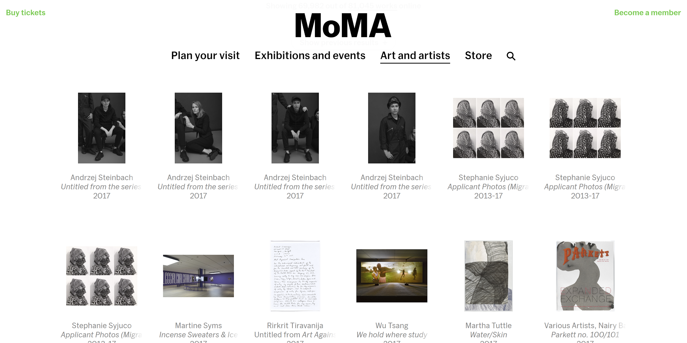

1. MoMA’s Webpage for Collection Section

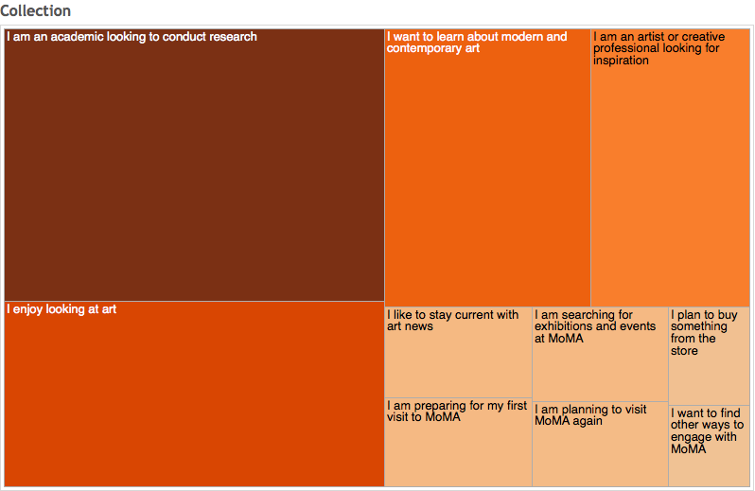

1. Motivations for visiting the MOMA’S collection on moma.org/collection (by Digital @ MoMA <https://medium.com/digital-moma/what-motivates-a-visit-to-moma-s-website-ebad33e67ef0> )

MoMA’s website, at least the collection section, could be freed from searching and restrict navigation. As Google Analytics has found for MoMA.org, A large part of the reason people use MoMA’s website is because they want to random browse without looking at something specific. (fig.2) What’s more, due to the prevalence of social media and search, only a quarter of people access the website through homepage, which in term indicates that if people are really searching for some artworks or artists, their first choice is Google instead of directly searching on MoMA’s website. [1] All these aspects implies that the webpage can be less critical to navigation, and could adopt a more playful interactive visualization form.

Our goal here is to find a non-traditional, serendipitous and playful way for user to get the most out of the core dataset MoMA has - the collections. We want to improve user experience of such online museums especially for people who are not experts of arts. The website we create should not only enable an easier exploration but should also reveal some trends.

The main contribution of our visualization - the virtual MoMA collection museum - are as below:

1. Allows users to playfully select and compare artists;
2. Reveals the color progression of artworks and of artists;
3. Recommends relative artworks based on art style which inspires users’ further exploration of the collections;
4. Transform the traditional educational way of displaying artworks online to an inspirational exploration tour.

# **Related work**

Virtual Museums are potential Museums produced on digital medium as new means of representing museal objects. As a supplement virtual museum that allow people to explore modern art, two key issues should be addressed in the design: A design and user experience process to encourage serendipitous artwork discoveries and a representation method to exhibit large collections of images.

## **Design for Serendipity through Visualization**

As a visualization designed to empower exploration for modern art, our key design rationale focuses on information representation as a means to support serendipitous discoveries in imaginary data collections. The Bohemian Bookshelf [2](fig.3), as a good case study, is a bookshelf visualization that was designed to facilitate open-ended exploration of digital library collections and serendipitous book discoveries. It points out several key issues which encourage users’ exploration: 1. Highlight adjacents: it is often items in close proximity that draw people’s attention and trigger on more explorations. 2. Enticing curiosity by considering visual metaphors, the representation of unusual data facets, and the incorporation of visual cues to facilitate the interpretation of the presented data. 3. Flexible visual pathways: It has been suggested that open-ended search strategies may benefit from visual interfaces that allow for flexible, rather than predetermined navigation[3].

Thus, the visualization replaces the current textual query editors and sequential result lists into a more interactive dashboard. Taking color encoding as the narrations through the whole story, which aims to uncover some latent color trend behind the art pieces.

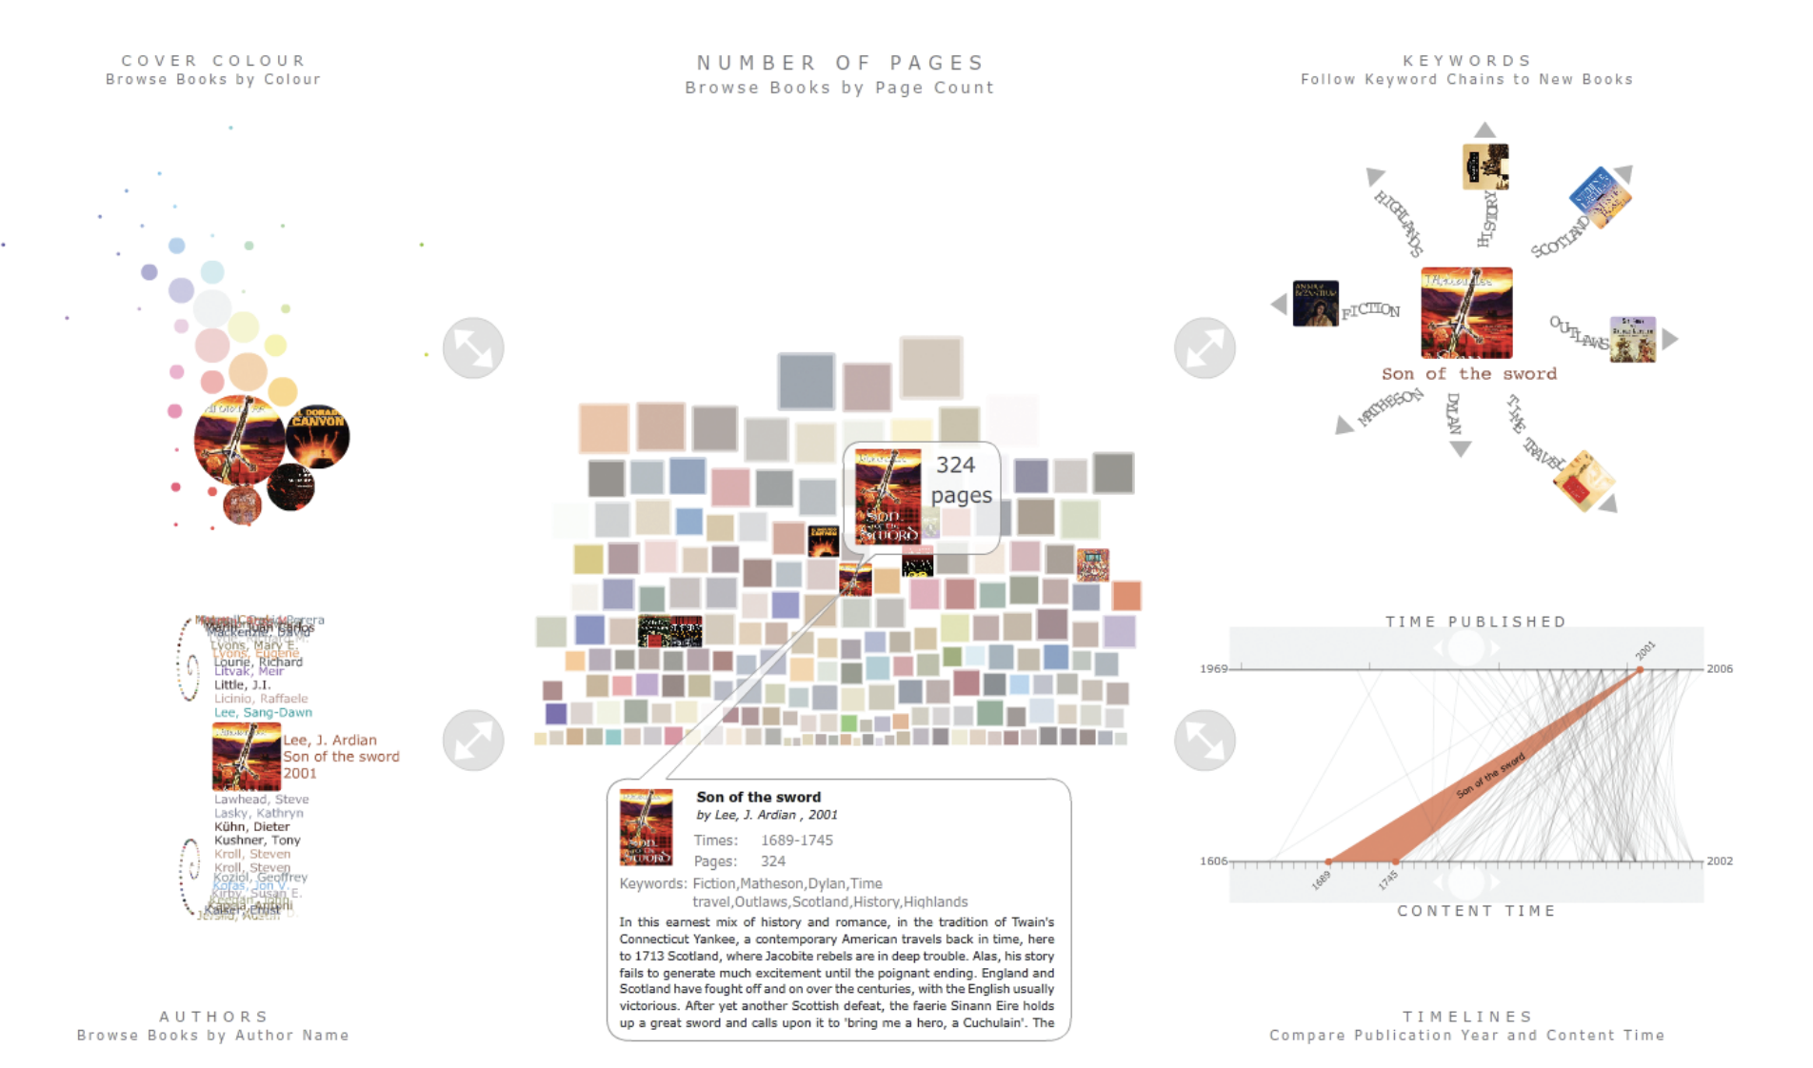

1. The Bohemian Bookshelf visualization

## **Visualizing Large Image Collections**

The New York Times created an interesting way of visualizing fashion for 2013 New York Fashion Week[4]. Dazzling collections were selected and presented in carousels (one for each designer). All images are really thin, only showing a glimpse of the main colors of the outfit. The user can see the full look with mouse hovering on the image. Inspired by the book Every Building on the Sunset Strip by Edward Ruscha(1996), an artist book which unfolds to 25 feet to show continuous photographic views of Sunset Boulevard, another project named *On Broadway* [5] (fig.4) folds google street view maps and instagram posts of street segments as slices. Users can click to expand the whole images and see more details.

* email address

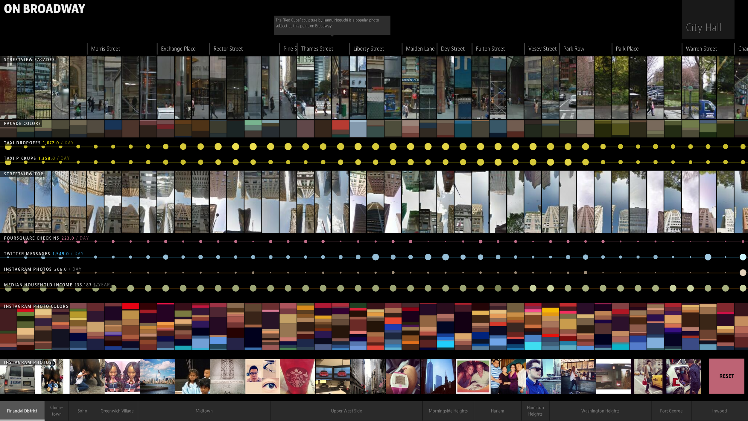

1. On Broadway visualization at level ii zoom-in

Such kind of images encodings allow large collections of images to compile together and reflect the dominant color field as an integral representation. To visualize large amount of art pieces on the website, we also used this folding techniques. .

# **Method**

Our starting point is to design a form of display that stimulates random exploration of the artworks. Therefore, allowing users to locate themselves in this enormous dataset avoids the sense of loss and on the other hand, ‘luring’ them to the final layer of information is important for this progressive exploration.

So we want to have a section giving an overview of the dataset at the beginning. We think such general perspective is helpful because users are able to get a sense of where the artists they’ve picked are in this huge dataset, and how many more they could still explore. Once users pick some artists, we want to present more detailed information of the artworks to them. Again, giving them an overview of all the artworks created by the artists help users locate and navigate through the artworks. Once they click on some specific artwork, they would be shown further details, like related art pieces. In general, this step-by-step process breaks the overwhelming information into small pieces and display them cumulatively guided by the users’ interest.

## **Data Visualization in D3**

The main structure of the visualization is several graphs nesting on each other. The first visualization, which is the color bar, allows users to select artists by randomly clicking on color blocks. With the selected artists, the data are passed to the second visualization where all the artworks of the selected artists will be plotted by clicking on the ‘Plot Thumbnail’ button. Then if the user click on a specific artwork, then a detailed caption and recommended relative artworks will appear in the box on the right. So in general, the three parts of visualizations are nested one on another, with selected data passed in between. All the visualization are built on D3, which greatly enables us to achieve animated visual effects by using the transition functions.

For the color encoding part, we really wanted to use the dominant colors which have the highest area ratio on canvass in artworks. However, the colors turned out to be really dark and gray-ish (fig.5). The saturation for all the colors is remarkably low. (see the graph below) It seems modern art has a prevailing preference for low-saturated colors. Such colors do reflect the dominant colors in artworks, but have quite limited visual expressiveness.

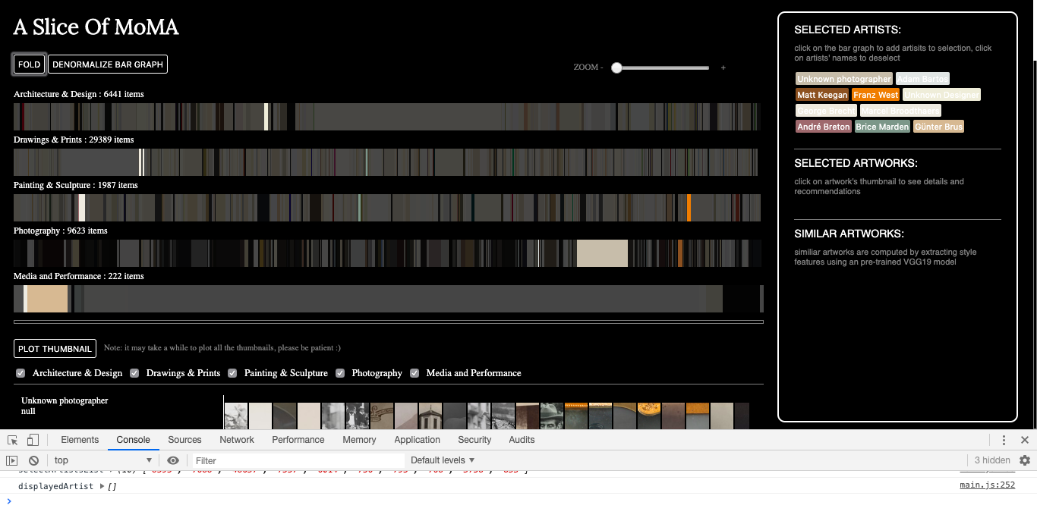

1. The Dark Color Palette with Highest Probability

In the end, we gave up on using the colors with the highest probability, instead choosing to use the colors with the highest saturation for all artworks (fig.6). “Distinct hues can be used to effectively convey category values, while changes in luminance or saturation can encode ordinal or quantitative differences.”[6] The refined color palette is much easier to read and distinguish, and adds a lot more vitality in the visualization.

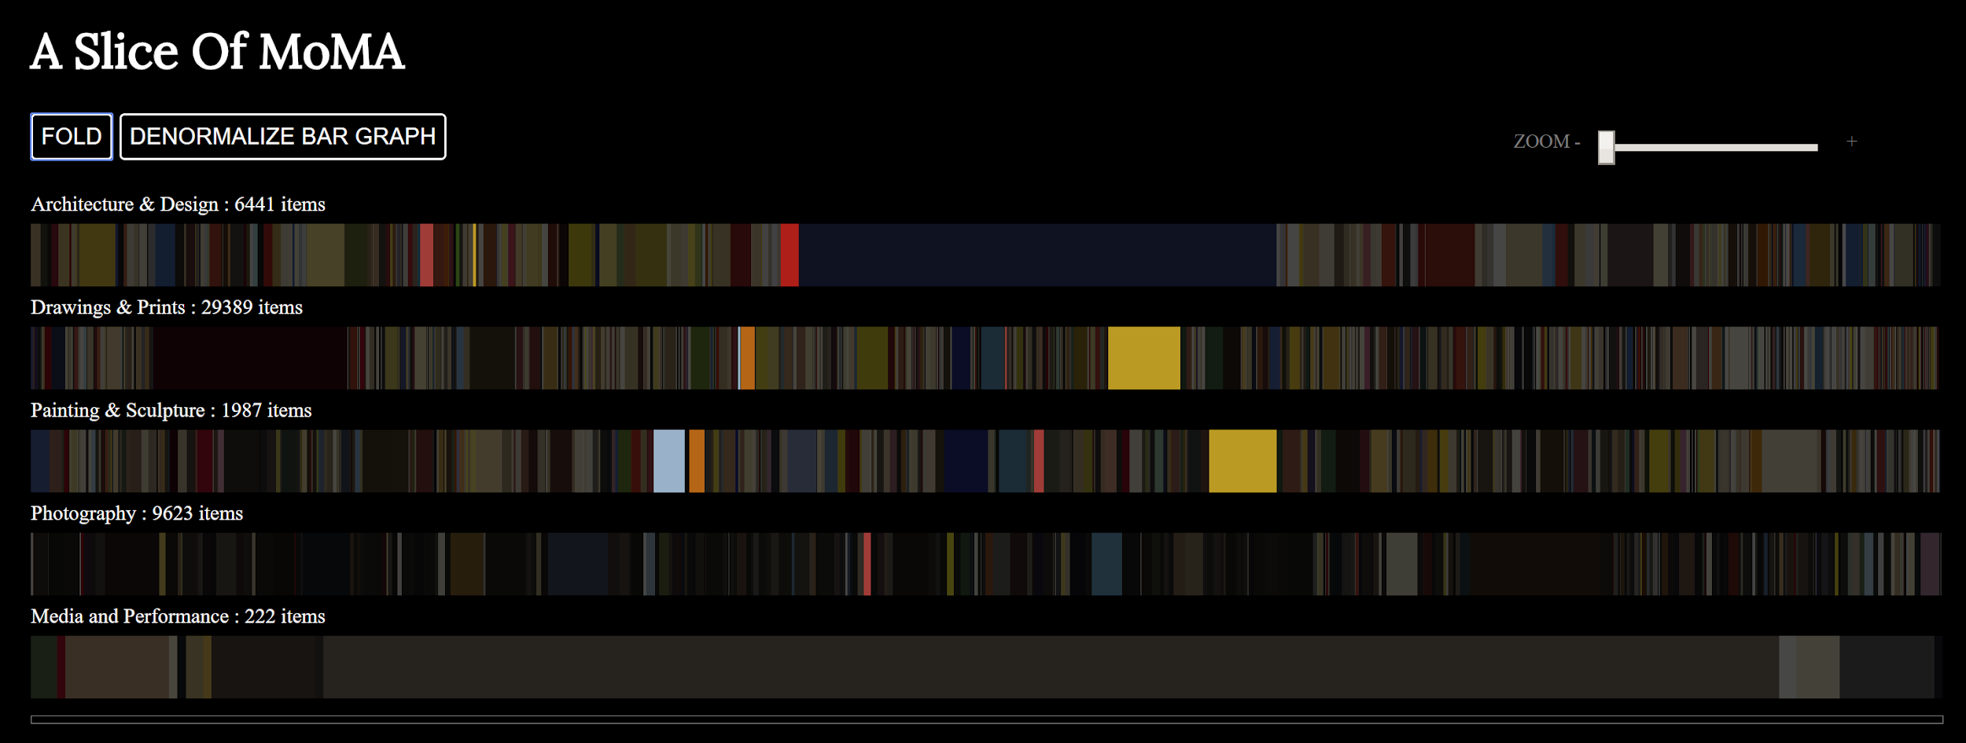

1. Modified Color Palette Using The Highest Saturation

## **Color Analysis**

In order to show the color usage in art works, we extract color analysis to get dominant colors in each images. The reason why we want to visualize the color analysis is that it might shed light on artists’ potential color preference or the overall trend in modern art through years.

We tried to directly count the sum of pixel numbers of different colors and pick up top instances. However, the top colors returned are very similar, eg (210,243,208) with a proportion of 23% and (205,226,213) with a proportion of 16%, which are basically both background paper color. It seems that just using the highest probability to return colors would not work here. Similar colors need be clustered and the actual colors to return should be the representative colors from the clusters. Therefore, we then apply k-means algorithm to cluster those pixels and assigned each pixel to its representative RGB value. We use 16 means in this visualization, group the number of pixels and calculate the percentage of each color.

Clicking on an image slice will unfold a bar chart of top-8 color map as the color encoding of the selected image. In the folding state, it only shows the most dominant one in the work. (fig.7)

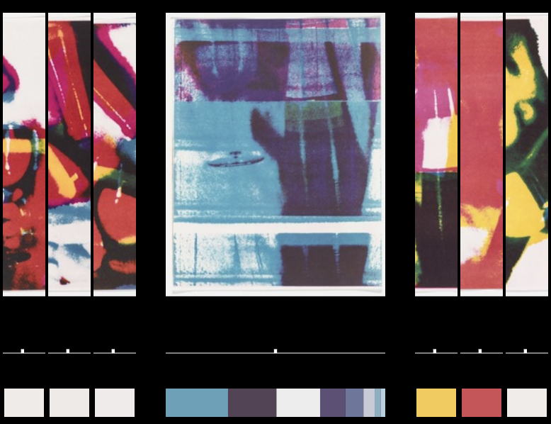

1. Encode selected images with top 8 dominant colors

## **Artwork Recommendation**

As mentioned in the Bohemian Bookshelf study, items in close proximity will draw people’s attention and trigger on more explorations. As a virtual museum designed for serendipity, we add a recommendation engine in the third section: detail information.

Since the whole project takes this unique perspective of analyzing artworks and artists by colors, the recommendation then uses a pre-trained VGG19 model for “style” to extract the representative vectors of images and then calculates the euclidean distance between them for the next-step recommendation.

The paper “A Neural Algorithm of Artistic Style”[7] showed how a convolutional neural network (CNN) can be used to "paint" a picture that combines the "content" of one image with the "style" of another. It uses the pretrained VGG19 model’s weights of the first layers in each of the five blocks to extract “style” information. In our project, limited by the computation power to calculate euclidean distance between high dimension vectors, we only take the first layer weights of the last block to apply to each image. We apply PCA to reduce features’ dimension and calculate distance between each image vectors.

The recommendation results are shown on the right side in the box. When clicking on one images, the right hand side will pop up detailed information of selected images, a link back to MOMA official website and five most similar images recommended to the users(fig.8). Hovering on the images, more information about these images will show up. Users may be inspired to explore the recommended artworks.

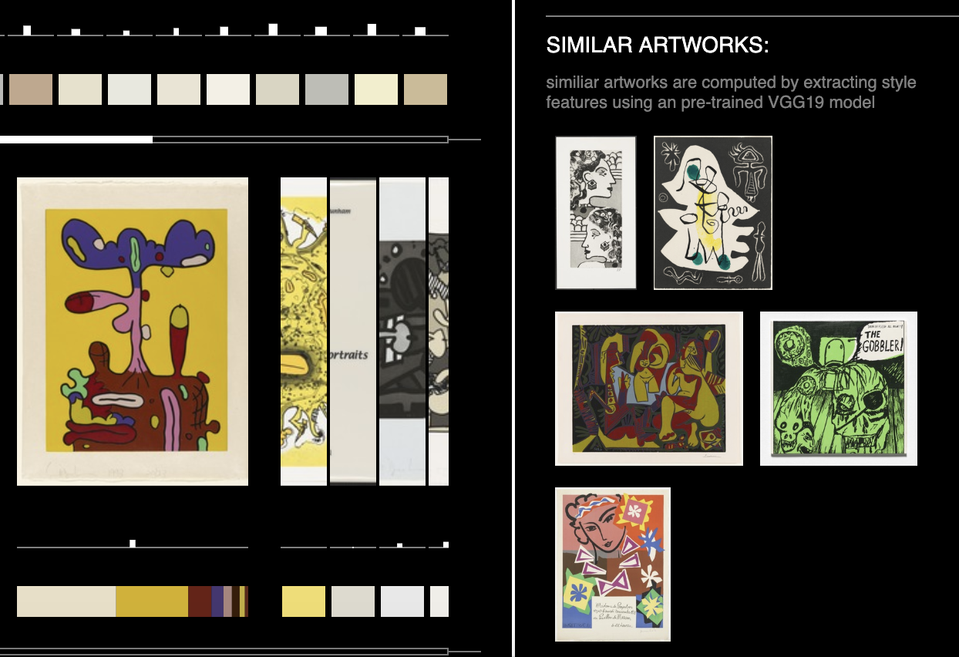

1. Recommending Top 5 Artworks

# **Result**

As discussed in the previous sections, ‘luring’ users in step by step until they get to the final depth of information is the key point of the ‘serendipitous exploration’ we want to create here. On the other hand, avoiding the feeling of loss in such process is crucial for users to have the interest in starting new explorations. Therefore, a sense of the whole picture and progressively unveiling the information are the two key strategies we want to carry out in the visualization.

Based on the two rules, the final result consists of a series of nested visualizations responding to users’ reaction.

*A color bar* - here in the bar, artworks are categorized into the departments in MoMA, such as architecture, drawings and photography. The artworks are then grouped by artists. Each artists are assigned with the brightest color they’ve used in their artworks. Then the color blocks are stacked to form a color bar of which the scale could be adjusted by a zoom bar on top right.

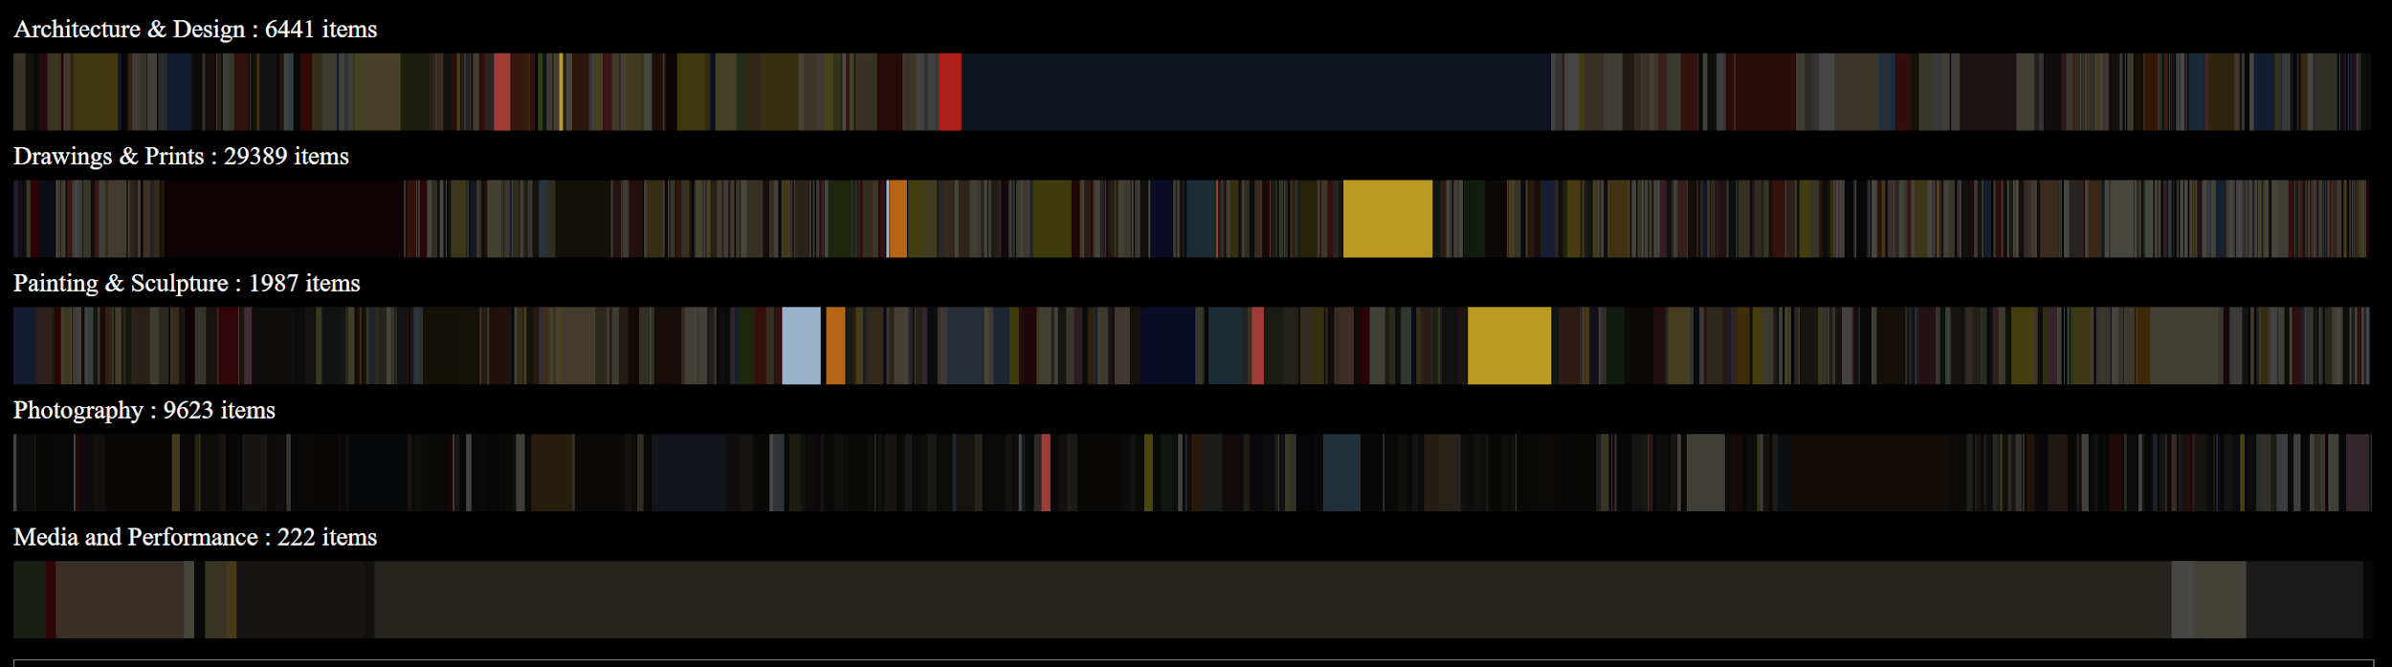

1. The Color Bar

*Plotted artworks* - this section is to display artworks with details. Once users select some artists, by clicking on the ‘plot thumbnail’ button, all the artworks are plotted. This part of visualization contains a few small segments. The main body is the artwork axis where user can scroll in both ways and also click on a specific artwork. After the click, the representative color block of that artwork will expand to a bar showing the top 8 colors used in the artwork with the length relative to the area ratio of the colors. On the left, a grid with cells representing each artwork shows the color progression of the artist.

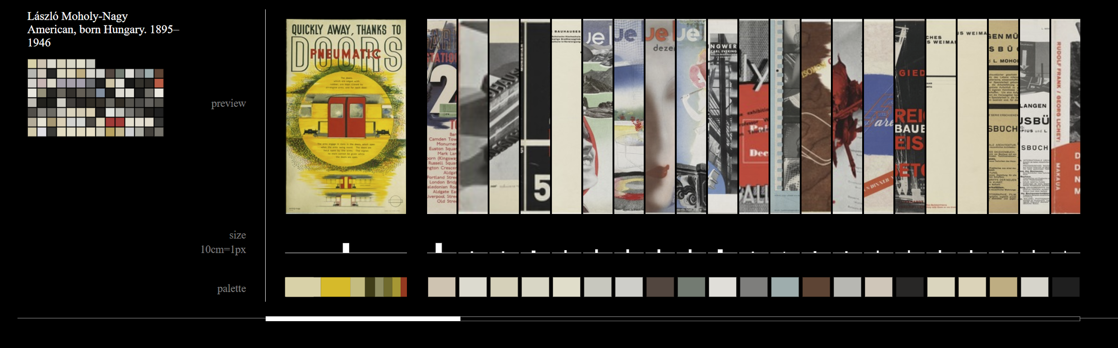

1. Plotted Artworks

*Detail and recommendation section* - the final part of the visualization contains a name-tag area - where by clicking on the tags, the selected artists can be deselected, a caption area showing the detailed description of the selected artwork, and a recommending area where the top 5 similar artworks will be displayed.

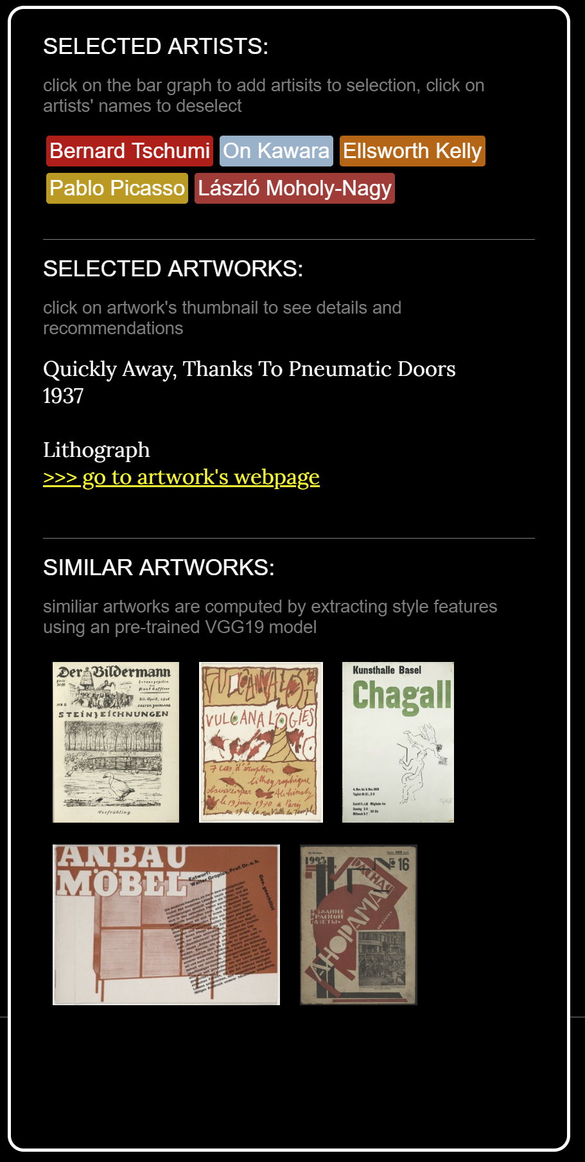

1. Detail and Recommendation Section

# **Discussion & Future Work**

We recorded some user feedback during the poster session to evaluate the overall system. In general, people showed a high level of acceptance and explored the system with little guidance, which achieved our goal of generating seperendity finding. Meanwhile, we also observed some user behavior that reflects some missing points in our design:

1. People still want to have the search function, or a clearer way to target the artist they are interested in. it seems the traditional navigation method is and still will be popular, especially among people over 50. Paralleled with the current exploratory selection on the color bar, we could add a search bar to allow precisely selection of the artists.
2. People showed great interest on the left hand side color grid, and expected interaction to get more information from the cells. Due to limited time, some ideas have not been realized on this part and it should definitely be part of the future work. People’s advice on sorting the matrix by some colors’ features such as hue, saturation, color temperature etc., will also be taken into consideration.
3. People tend to click on the the recommendations to load more information. By clicking on the images, artists of the related work and the work itself should be highlighted in the color bar, or the page should be redirected to the official MoMA website. This would complete the serendipitous exploration.

We would like to keep exploring the different methods of extracting meaningful color information from the artworks, and making recommendations of similar artworks. We would like to show the different methods to users as options, so they can choose the ones that best suit their needs, and get to understanding more on the logic behind those algorithms.Besides, we would like to add more interactions to the recommended artworks

Also, we would like to reach out to MOMA to see if there are any possible collaborations that would bring this visualization to the public.

**References**

1. Foe, Digital @ MOMA. "What motivates a visit to moMA’s website?"<https://medium.com/digital-moma/what-motivates-a-visit-to-moma-s-website-ebad33e67ef0>
2. Thudt, Alice, Uta Hinrichs, and Sheelagh Carpendale. "The bohemian bookshelf: supporting serendipitous book discoveries through information visualization." Proceedings of the SIGCHI Conference on Human Factors in Computing Systems. ACM, 2012.
3. Marchionini, Gary. "Exploratory search: from finding to understanding." Communications of the ACM 49.4 (2006): 41-46.
4. Mike Bostock, Shan Carter, Erik Hinton, Cathy Horyn and Eric Wilson. "Front row to fashion week".New York Times
5. Daniel Goddemeyer, Moritz Stefaner, Dominikus Baur, Lev Manovich. "On Broadway"
6. Poco, Jorge, Angela Mayhua, and Jeffrey Heer. "Extracting and retargeting color mappings from bitmap images of visualizations." IEEE transactions on visualization and computer graphics 24.1 (2018): 637-646.
7. Gatys, Leon A., Alexander S. Ecker, and Matthias Bethge. "A neural algorithm of artistic style." arXiv preprint arXiv:1508.06576 (2015).